Setting up your Microsoft Exchange email on Android devices
- Under Applications select Email. In several versions of Android, this application could be called Mail.
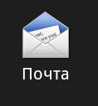
- Select Set Up Manually.
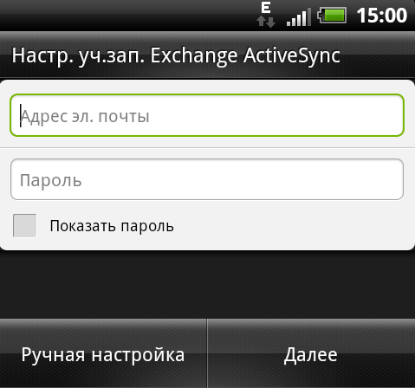
- Select Exchange Account. In several versions of Android, this may be called "Exchange ActiveSync."
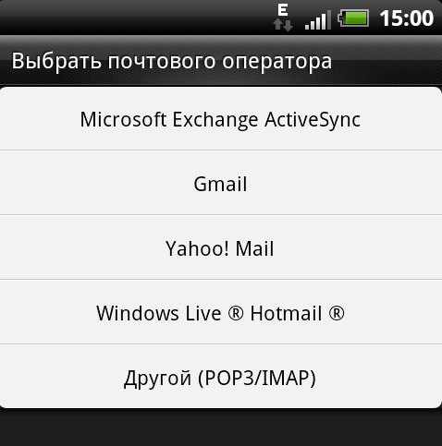
- Enter the account details mentioned below and then click Next.
- Domain\Username. Enter your full email address here. If the Domain and Username in your version of Android are two different fields, leave Domain empty and enter your full email address in the Username section.
Note: In certain versions of Android, the format ‘domain\username’ must be used in this field. For example, if your email is proverka@contoso.com, enter contoso.com\proverka@contoso.com. The username is the email address you use.
- Password. Enter the password you use to access your account.
- Exchange Server. Enter the server address Exchange Server. For information on how to determine this, see the section ‘Determining the name of the Exchange ActiveSync server' later in this article.
- As soon as your phone checks the server's settings, the Account Settings screen will appear. The settings that can be accessed depend on the version of Android installed on the phone. The settings mentioned below may be available.
- Intervals for checking emails. The Push option will automatically send messages to your telephone when they are received. This feature is recommended only if you have unlimited Internet access.
- Synchronization period. Determines the number of messages required to be saved on your mobile phone. Several options can be chosen, such as 'one day,' 'three days' or 'one week.'
- Notifications of new messages. If this option is selected, you will receive notifications to your phone when you receive new emails.
- Synch contacts with your account. If this option is selected, contacts on your phone and on your account will be synched.
- Secure Socket Layer (SSL) This function should be turned on.

- Select Next, then enter the name of the account and the name to be shown when sending messages to other users. Select Done to finish setting up your email and begin using your account.
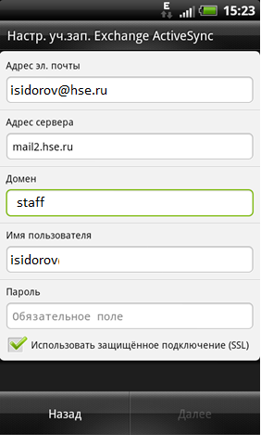
Note. Before you can send or receive emails, you may need to wait 10-15 minutes after configuring your account.

