USEFUL LINKS and APPS
for Newcomers and Residents
Contents
Working at HSE University 2
Transport and Navigation 2
Taxi Apps 2
Metro and Maps 2
Car Sharing and Rental 2
Mobile Operators 2
Shopping Online 3
Online Marketplaces 3
Groceries 3
Food Delivery 3
Pharmacy 3
Home Appliances and Electronics 3
Entertainment and Travelling 3
Entertainment 3
Travelling 4
Learning Russian 4
Other Services 4
Popular Social Media 4
Cleaning Services 4
Coupons and Cashback 4

Working at HSE University
- RUZ (Rus. РУЗ, Расписание учебных занятий) – Timetable organizer. This also allows you to check for free classrooms (available in English);
- LMS – the Learning Management System provides instruments for better communication of teachers, students and managers;
- HSE Navigation app. Download a map of the University’s buildings from Google Play or App Store;
- HSE Personal Account (Rus. ЛК, Личный кабинет) – a system with a comprehensive range of educational, scientific, administrative and other services (only available in Russian);
- HSE Glossary. This thesaurus was created to ensure consistency in terminology and suggest names for new subdivisions or units at HSE University.

Transport and Navigation

Taxi Apps
- Yandex Taxi
- inDriver
- RuTaxi
- Uber
- Gett (Get Taxi)
Please note that most drivers do not speak English.
The following companies have English-speaking operators and drivers:
- Angel-Taxi, Tel. +7 (495) 956 0800
- LingoTaxi, Tel. +7 (495) 204 21 34

Metro and Maps
- Moscow metro map
- Yandex transport and Yandex maps
- 2GIS maps
- Aeroexpress can help you to reach airports

Car Sharing and Rental
- Delimobil
- Belka CAR
- VeloBike – bicycle rentals

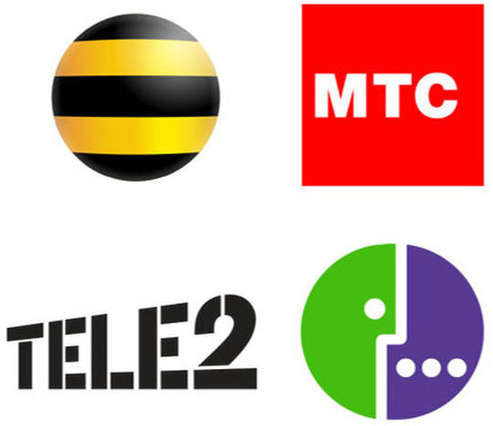
Mobile Operators
- MTS
- Beeline
- Megafon
- Tele2

Shopping Online

Online Marketplaces
- Ozon (Russian version of Amazon): This online shop provides more than 5 million positions in dozens of categories
- Beru! (Rus. Беру!)
- Wildberries

Groceries
- Online supermarket Perekrestok
- Online supermarket Utkonos
- Online supermarket METRO Cash&Carry
- Yandex Lavka
- Samokat
- SberMarket

Food Delivery

Delivery Club is a very popular mobile and desktop platform for food deliveries.

Yandex Food delivery

Dostavista is a popular delivery service - you can order food, flowers, gifts, etc.

Pharmacy
- The online pharmacy Apteka.ru makes delivery to 726 pharmacies – you can choose the nearest one;
- Online pharmacy Gorzdrav

Home Appliances and Electronics
- Holodilnik
- M Video
- Eldorado
- DNS

Entertainment and Travelling

Entertainment
Visit any of the sites below to plan a theater trip or an art-crawl, a movie night or a sporting event:
- KudaGo
- Movies: SubsCity provides information about all movies showing in Moscow cinemas in their original language
- Tickets services: Ticketland, Kassir, Parter
- Russian Museums

Travelling
- Russian Railways
- Yandex Schedule
- Tutu app (airline tickets, railway tickets, bus tickets, hotel bookings, etc.)

Learning Russian
- Duolingo – app for learning Russian
- Busuu - app for learning Russian
- Voice translator: Say and translate
- HSE University Russian Language Centre
- MGU Russian Language Centre
- RUDN University Learning Russian for Foreigners
- Maurice Thorez Institute of Foreign Languages – Russian language courses
- Russian Language School
- Liden & Denz Intercultural Institute of Languages

Other Services

Popular Social Media
- WhatsApp messenger
- Vkontakte social network

Cleaning Services
- Qlean
- SVcleaning

Coupons and Cashback
- Biglion: coupon service - you can choose and buy service or product with a decent discount.
- LetyShops gives the option for cashback while shopping in different stores: AliExpress, ASOS, Ozon, Lamoda, M. Video and others.
- SberFood app allows you to book a table in a restaurant/café, pay online, order dishes online, and discounts and special offers.

